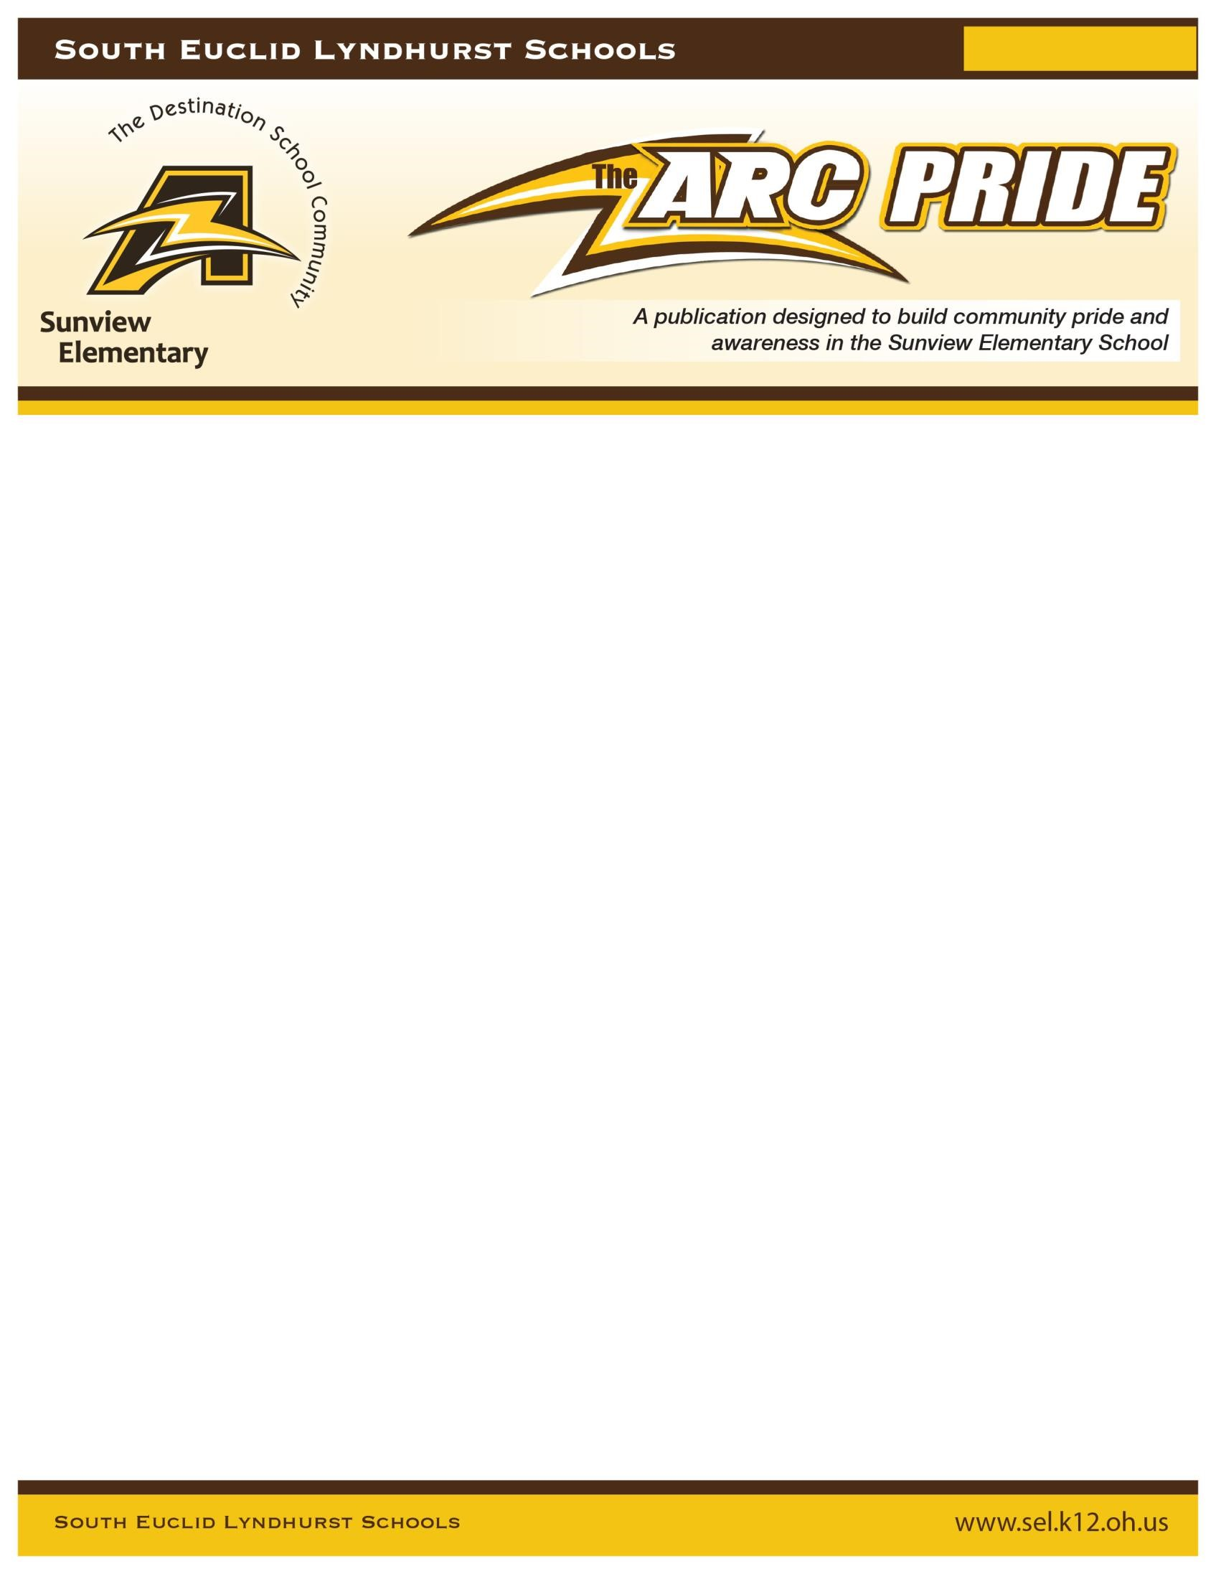

Volume 1 / Issue 1

Greetings, Sunview Families!

It is my pleasure to reopen and welcome back students into the

building!

Thank you for your support during remote learning.

Your parental
involvement has allowed
us to accomplish a great deal under these circumstances.

I am honored to know that you have
imparted the trust of your child in our care during these unprecedented times. I realize there have been
unexpec
ted changes to staffing for

the second

quarter, but please know we have worked really hard to
minimize these changes.

Continue

to remain positive and know that
children

are resilient and will adapt
well, with our collective support.

The goal of this mailer is to provide you with a
dditional details to
further ease your mind regarding your child’s safe transition back to Sunview.

School resumes on Monday, November 9, 2020.

Students will physically attend school on
Mondays, Tuesdays, Thursdays and Fridays (unless otherwise noted on t
he district
calendar).

ARCS Wednesdays will operate as it has been during remote learning.

You are still
required to complete the weekly ARCS Wednesdays Attendance Form online.

GENERAL SCHEDULE

8:10

Students may arrive on campus

8:10
-
8:25

FR
EE

Breakfast available to all students (eaten in the classroom)

8:25
-
8:45

Morning Meeting

8:45
-
11:00

English Language Arts

11:00
-
11:30

Kindergarten Lunch

11:15
-
11:45

1
st Grade Lunch

11:30
-
12:00

2
nd Grade Lunch

11:45
-
12:15

3
rd Grade Lunch

12:15
-
2:00

Math

2:00

Dismissal

*Although there is no scheduled recess, teachers will incorporate movement breaks throughout the day.

TARDIES/ABSENCES
Please call the school office, if your child will be absent. It is helpful to notify us of the reason for the absence as well. Please call the office no later than 9:00 AM to report an absence and to avoid an automated voicemail message. Unexcused absences and tardies will be monitored. Successive absences or tardies may result in your being contacted by the Principal, counselor, or district attendance officer.
Students arriving to Sunview after 8:45 AM are deemed tardy and MUST be accompanied by an adult to the Welcome Center to sign in child late to school. Parents must wait to have their child’s temperature cleared. Please park in a visitor parking space. No parking allowed along the front, main oval and no dropping off child without signing them in!
Vacations are considered unexcused absences. Please complete a Vacation Form if your family will be vacationing during the school year.

BREAKFAST & LUNCH
We encourage all of our families, regardless of income, to take advantage of our FREE breakfast and lunch program. Food will be FREE through the end of the year. It will be delivered to your child’s classroom daily.
As an alternative, students may bring a packed lunch. Please make sure your child’s name is on the outside of his/her lunch box/bag. Do not send glass bottles, jars, or any type of cutlery (including plastic knives) to school.

COVID-19/HEALTH GUIDELINES
As we reopen the school, it is essential that our protocols are in alignment with the state’s 5 Pillars of health & safety:
Strategy 1: Vigilantly Assess for Symptoms (We will conduct daily temperature screenings and monitor COVID-like symptoms.)
Strategy 2: Wash and Sanitize Hands (Hand sanitizer stations are located at all student entry doors as well as classrooms.)
Strategy 3: Thoroughly Clean and Sanitize (Our custodians have established robust disinfection routines.)
Strategy 4: Practice Social Distancing (Our desks will maintain 6 feet apart in the classrooms; hallway transitions will be limited throughout the day.)
Strategy 5: Implement Face Covering Policy (All K-3 students and staff must wear a mask.)

Please watch our TOGETHER SAFELY IN SEL SCHOOLS VIDEO with your child before Monday.
Upon the order of the Ohio Department of Health, all K-12 schools must report all cases of COVID-19 in their schools and provide notification to parents and guardians. The order also states that parents and guardians are encouraged to report positive cases to schools.
Should we receive notification that at least one student or staff member in our building or school bus has tested positive for COVID-19, each case of COVID-19 will be interviewed by the CCBH.
For more information, please visit our district website: https://www.sel.k12.oh.us/COVID19Update.aspx
In order to maintain the health and wellness of our students, we ask that you notify our office immediately if your child contracts a contagious, communicable disease (such a strep, lice, ring worm, etc.) It is part of our procedures to inform other families of the exposure to such a disease. In addition, please note that if your child is ill, s/he should not come to school per the COVID Contact agreement form you returned. Please be prepared to make arrangements to pick up your child from school, if the school nurse deems it necessary for your child to leave campus.

MEDICATION AT SCHOOL
Will your child need to take prescribed medicine during the school day? Medical Authorization forms are available in the office. The form must be SIGNED and completed by a physician. Regardless of previous notifications on file, current documentation is required before dispensing medication at school. If there are updated health concerns that our clinic needs to be made aware of, please contact our school nurse ASAP.

SCHOOL SUPPLIES
Below are the links for requested supplies by grade level:
KDG Supply List First Grade Supply List
2nd Grade Supply List 3rd Grade Supply List
A FULLY CHARGED CHROMEBOOK should be brought to school daily. When supplies are brought to school, please make sure the items are clearly labeled, as materials will not be shared.

STUDENT DRESS CODE
Please dress your child comfortably for the weather and more importantly for the climate in the classroom. Layers are encouraged in case windows are open for ventilation. Closed toes and heeled shoes and socks are required for school. A complete dress code may be found online in the K-3 Student Rights and Responsibilities Handbook. (Due to the closing of our water fountains, we do allow students to bring a clearly labeled water bottle as the water fountain will be off limits.)

ARRIVAL TO SCHOOL
Students must not arrive to Sunview earlier than 8:10 am.
Car Line- Enter the parking lot area in front of the playground beginning at 8:10am. If the lot is full the car line continues on Meadow Wood. While waiting in line, do not block intersections or residential driveways. Please remain 30 feet behind the stop signs. Put on your hazard lights while waiting to indicate that you are entering the school lot. KEEP YOUR CHILD IN THE CAR UNTIL HIS/HER TEMPERATURE IS TAKEN BY A STAFF MEMBER. Have the student seated in the back passenger side of the vehicle, and roll his/her window down. The child should stick his/her wrist out of the window. Students must have a normal temperature reading in order to exit the car. If a fever above 100 is present, the child must be taken home; Students with normal temps will be allowed to enter the building with a mask on. If a child arrives after 8:45am, a parent must park in the lot and escort the child in the Welcome Center to receive a temperature screening.
The car drop-off line in the morning is a single lane of traffic. Once your child has exited your car on the curbside, please stay in the line until the car(s) in front of you has moved forward. Please pull up as far as possible so that multiple children may exit their cars at curbside. Neither drivers nor children are permitted to exit their vehicles in the car lane for any reason. Adults must always remain in their vehicle during the car line. Please follow the directions of the staff members on duty for the efficiency of the car line.
Bus Riders- Students’ temperatures will be checked by a bus monitor prior to boarding; if a fever is present, the child will not be permitted to ride the bus; children with a normal temperature will board the bus wearing a mask. They will be assigned to a seat to themselves (unless there is a sibling). Upon arrival to school, students will enter the front doors where they will be escorted to the gym.
Walkers- Wearing masks, walkers will stand on markers in front of the flagpole door, waiting in line to receive a temperature screening. Students with normal temperatures will be allowed to enter the building.
DISMISSAL is from 2:00-2:15pm.
In order for us to dismiss your child safely in the afternoons, it is imperative that you complete our SUNVIEW DISMISSAL FORM indicating your child’s plan after school.
Students will remain in the classroom until called on the PA and/or two-way radio.

BUS RIDERS will report to the gym and sit on designated markers/cones to ensure safe exiting.

WALKERS will dismiss from the flagpole door once a parent is identified. Use the sidewalk and crosswalks for safety.

CAR LINE- PLEASE NOTE CHANGES TO THE SUNVIEW DISMISSAL PROCEDURES.

CAR LINE FOR GRADES K-1

Please slowly enter the parking (playground) lot area. If the lot is full the car line overflow continues on Meadow Wood. While waiting in line, do not block intersections or residential driveways. Please remain 30 feet behind the stop signs. In the afternoon, the line is a double lane. A staff member will assist to moderate the flow. Once your child has entered your car on the curbside, please stay in the line until the car(s) in front of you has moved forward. Adults must always remain in their vehicle during the car line. Please follow the directions of the staff members on duty for the safety of the car line.

CAR LINE FOR GRADES 2-3
The pick-up area is in the front main oval at 2:05PM. Without blocking driveways, crosswalks or intersections, please slowly pull into the FRONT MAIN OVAL ENTRANCE AFTER OUR BUSES LEAVE AT 2:05PM. You may not linger on the street or come into the lot before 2pm. Cones will be up blocking entrance so as only to allow buses.

This will be a single, curbside only pick up. Staff Members will assist to moderate the flow. Once your child has entered your car on the curbside, please stay in the line until the car(s) in front of you has moved forward (unless directed to safely maneuver by a staff member. Adults must always remain in their vehicle during the car line. Please follow the directions of the staff members on duty for the safety of the car line.
***NOTE: Please be patient as the car line will move slowly for the first few weeks until all parties are acclimated with the routine.
***Car line signs will be given to students on the first day who are identified as daily car line riders. Please display the signs in the AM & PM pick up lines.

After Care- Daycare vans may enter the front main oval. Please ensure daycare vans are aware of our dismissal time (2:05pm) and our pick up rules.
Changes to Dismissal Plan If there is a change in your child’s dismissal procedure (such as s/he will be picked up instead of riding the bus), we MUST have a written, dated, signed note/email from a parent with this information. Otherwise, if there is no parental correspondence, the child will go home in his/her usual way.

VISITING SUNVIEW
Due to COVID -19 restrictions, we are limiting visitors in the building. Should you need to meet with a staff member, you must arrange an official and confirmed appointment.

BIRTHDAYS
Birthdays are special to children, and we will acknowledge birthdays in the classroom, if
desired. Unfortunately, we will not celebrate through edibles or party favors. The teacher will not be allowed to send home Party Invitations at this time. Our office will not provide addresses and phone numbers to other families.

Behavior
We expect students and staff to demonstrate mutual respect and kindness. To support this endeavor our district has received training in Conscious Discipline and Positive Behavior and Intervention Support. Clear rules and expectations are established, rewards and consequences are determined, social skills are modeled and self regulation strategies are taught.
When it comes to behavior and academics, Sunview students are encouraged to reach for the STARS:
- Stay Safe
- Take Responsibility
- Attend and Remain Focused
- Respect Self, Others, and Property

I SINCERELY LOOK FORWARD TO WORKING WITH YOU AS WE TRANSITION STUDENTS TO
SCHOOL. IF YOU HAVE NOT ALREADY DONE SO, PLEASE DISCUSS WITH YOUR CHILDREN THAT IT IS IMPORTANT TO FOLLOW ALL OF THE SAFETY RULES. HERE ARE A FEW KEY REMINDERS TO GIVE YOUR CHILD:
- KEEP YOUR MASK ON, UNLESS IT IS TIME TO EAT
- NO SHARING OF MATERIALS
- SANITIZE AND WASH HANDS FOR AT LEAST 20 SECONDS
- MAINTAIN SOCIAL DISTANCE
- GIVE YOUR FRIEND AND TEACHERS SAFE GREETINGS OTHER THAN HUGS
- IF FEELING SICK, PLEASE STAY HOME TO KEEP THE SCHOOL SAFE
Please feel free to contact me at taylora@sel.k12.oh.us with additional questions.
Yours in education,
Mrs. Taylor, Sunview Principal

